VISVESVARAYA TECHNOLOGICAL UNIVERSITY
BELAGAVI 590014, KARNATAKA



A MINI PROJECT (BCS586) SYNOPSIS ON
“AttendSmart: Proxy-proof, Insightful, Effortless.”

A dissertation work submitted in partial fulfillment of the requirement for the award of the degree of

BACHELOR OF ENGINEERING
IN
ARTIFICIAL INTELLIGENCE AND MACHINE LEARNING

Submitted by

Rakshitha S P | 1EW23AI045
Krishna C | 1EW23AI024
Yashas V Gowda | 1EW23AI059
Mohammad Nuhan | 1EW23AI029

Under The Guidance of
Dr. Usha B S
Professor
Department of CSE, EWIT



EAST WEST INSTITUTE OF TECHNOLOGY
DEPARTMENT OF ARTIFICIAL INTELLIGENCE AND MACHINE LEARNING

No.63, Off Magadi Road, Vishwaneedham Post, Anjananagar, Bengaluru-560091.
2025-26

TABLE OF CONTENTS

- Abstract 3
- Introduction 4
- Literature Survey 5
- Research Gap 6
- Problem Statement 7
- Proposed System 8
- Attendsmart System Architecture 9
- Objectives 10
- Methodology 11
- Multi-Modal Attendance Flow 12
- System Requirements 13
- Functional 13
- Non-Functional 14
- Hardware & Software 15
- Feasibility & Scope 16
- Privacy, Ethics & Risk Mitigation 17
- Expected Outcome 18
- Applications 19
- Bibliography 20

ABSTRACT

AttendSmart is a secure, multi-modal attendance platform that unifies face recognition, voice verification, QR code scanning, fingerprint authentication, and geofencing to deliver proxy-resistant, low-latency check-ins for classrooms and campuses. By automating the end-to-end process and adding real-time analytics with engagement features like streaks and badges, the system reduces manual effort, deters impersonation, and enables timely, data-driven interventions that improve participation and learning outcomes. Built with privacy-by-design and strong encryption, AttendSmart couples reliability and speed with institutional trust—making attendance effortless, insightful, and ready for scale.

INTRODUCTION

Traditional attendance methods—roll calls, RFID cards, and single-modality biometrics—consume valuable instructional time, remain vulnerable to proxy/buddy-punching, and provide little to no visibility into engagement patterns. As institutions embrace digital transformation and accountability, there is a clear need for solutions that are fast, fraud-resistant, privacy-aware, and capable of turning raw presence data into meaningful academic insights.

AttendSmart addresses this need through a multi-modal verification pipeline that prioritizes face and voice while seamlessly falling back to QR or fingerprint authentication, verified by geofencing when appropriate. The platform pairs instant check-ins with real-time dashboards, automated notifications, and gamified nudges that encourage consistent attendance—without sacrificing privacy or usability. By combining robust security, inclusive design, and actionable analytics, AttendSmart sets a new benchmark for attendance management: minimal friction, maximum trust, and measurable impact for educators, students, and parents alike.

LITERATURE SURVEY

Paper and Source | Description | Advantages |  | Disadvantages
Face Recognition with OpenCV (IEEE) | Camera-based face detection for automated marking | Quick to deploy; automates attendance | Sensitive to lighting/occlusions; single-modality limitations
QR-Based Attendance (IJSR) | Session QR scanning by students | Device-agnostic; low cost; fast rollout | Proxy risks via code sharing; manual session management
Multi-Modal Biometrics (ACM) | Fusion of face, fingerprint, and voice | Higher accuracy; strong proxy resistance | Added implementation complexity; possible hardware needs
Geofencing/IoT Presence (Springer) | GPS/IoT validation of physical presence | Strengthens location assurance; complements biometrics | GPS drift/battery impact; requires privacy guardrails and consent

RESEARCH GAP
Current systems are either single-modality, lacking robust fallbacks, or provide limited analytics and engagement, leaving institutions without reliable proxy prevention or actionable insights; AttendSmart fills this gap with multi-modal verification, fallbacks, and real-time dashboards.

PROBLEM STATEMENT

Design and validate an AI-assisted, multi-modal attendance system that eliminates proxy attendance, minimizes manual overhead, and provides real-time analytics for students, faculty, and administrators.

PROPOSED SYSTEM
AttendSmart orchestrates face (MediaPipe), voice (Web Speech), QR (jsQR), fingerprint (WebAuthn), and geofencing with confidence-based fallbacks to ensure reliable and rapid authentication under diverse device and environmental conditions. The platform offers real-time dashboards, gamified engagement, push/SMS notifications, offline caching with secure sync, and enterprise-grade security with JWT, RBAC, and encryption in transit and at rest.

Figure 1:

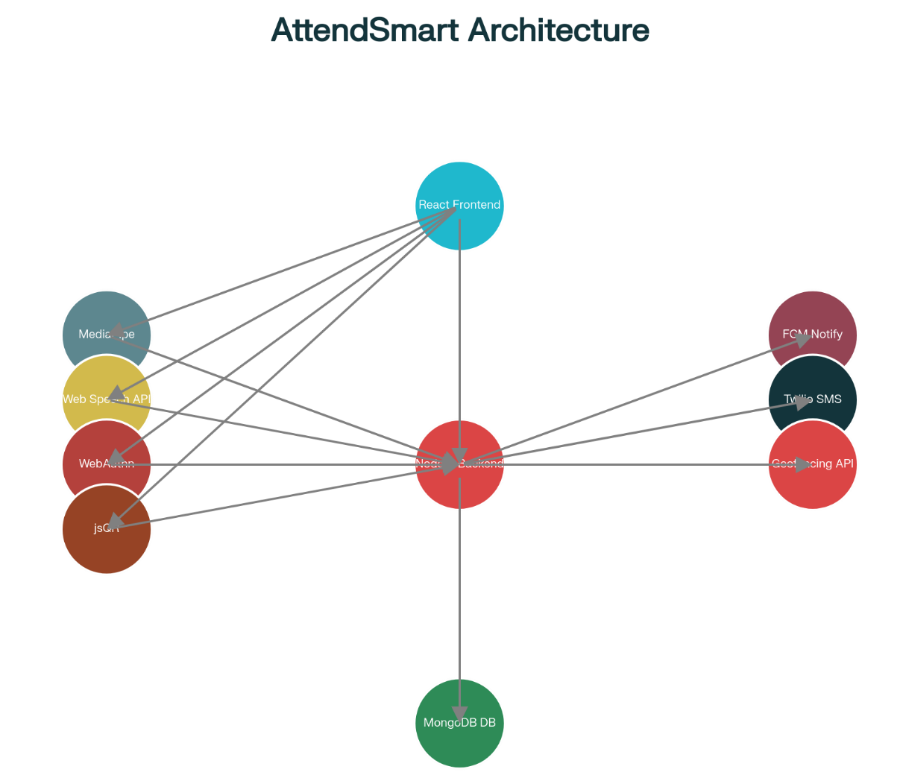
AttendSmart System Architecture
(React/React Native clients ↔ Express API ↔ MongoDB Atlas; MediaPipe, WebAuthn, Web Speech, FCM/Twilio as auxiliary services).

OBJECTIVES

AttendSmart aims to deliver robust, proxy-resistant verification by combining multi-factor biometrics with geofencing, while optimizing the end-to-end flow and fallback logic to keep average check-in latency near 15 seconds under normal conditions. To boost engagement and consistency, the system incorporates streaks, badges, and timely reminders, and it equips faculty with real-time analytics that correlate attendance with performance to enable early, data-driven interventions. Throughout, AttendSmart enforces strong privacy and security through encrypted storage, secure transport, explicit consent, and role-based access controls, ensuring trustworthy and compliant operation.

METHODOLOGY

Development:
Iterative sprints with CI/CD, code reviews, and automated tests to ensure quality and cadence.

Multi-Modal Flow:
Primary face + voice with automatic fallback to QR or fingerprint based on confidence, device capability, and context.

Data & Analytics:
Aggregations for attendance rates, streaks, and trend/correlation views at class and individual levels.

Deployment:
Cloud-hosted Node.js/Express API backed by MongoDB Atlas; containerized auxiliary services for portability and scale.

Figure 2:

MULTI-MODAL ATTENDANCE FLOW
(App launch → Geofencing check → Face/Voice auth → Failure triggers QR/Fingerprint fallback → Confirm → Sync/Notify).
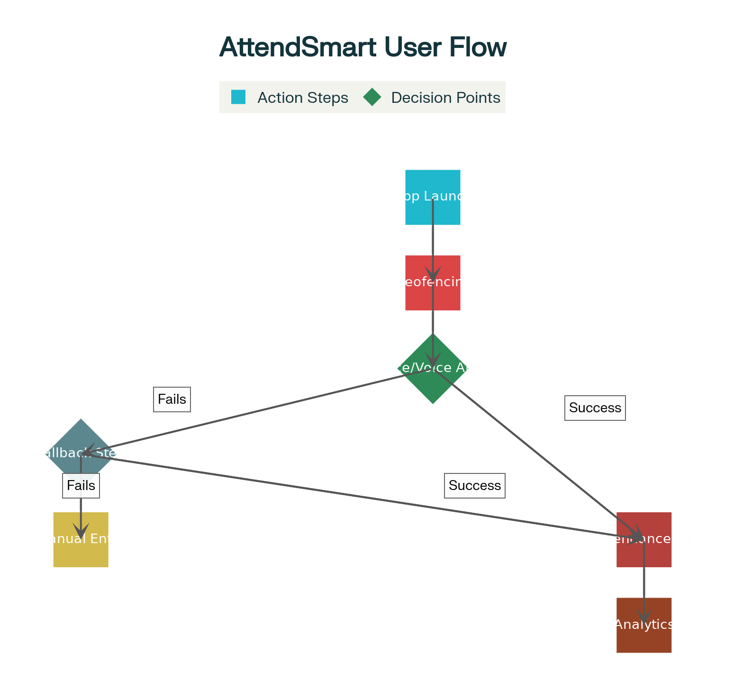

AttendSmart Student Attendance Flow

SYSTEM REQUIREMENTS

System Requirements — FUNCTIONAL

Role-Based Access:
Student, Faculty, Admin with JWT sessions and RBAC policies.

Multi-Modal Check-In:
Face, voice, QR, fingerprint, geofencing with configurable thresholds and full audit trails.

Real-Time Logging:
Time-stamped, device/location-aware entries with confidence metadata.

Dashboards & Reports:
Class trends, individual streaks, and correlation summaries for decision support.

Notifications:
Push and optional SMS/email confirmations, reminders, and exception alerts for late/absent cases.

Offline Mode:
Store-and-forward cache with conflict handling and secure background sync.

Admin Tools:
Session scheduling, manual override with justification and audit, CSV/Excel export for records.

System Requirements — NON-FUNCTIONAL

Performance:
Typical check-in ≈ 15 s with graceful degradation and timeouts under adverse conditions.

Reliability:
Consistent operation across lighting/noise/device variability via layered fallbacks and device-capability detection.

Security & Privacy:
TLS for transport, encryption at rest, key/secret management, user consent and data minimization by design.

Scalability:
Stateless services and horizontal scaling to support concurrent class/session peaks.

Usability & Accessibility:
Clear prompts, error states, and WCAG-aligned UI patterns to reduce friction.

Maintainability:
Modular codebase, API docs, structured logs/metrics for quick diagnostics and support.

System Requirements — HARDWARE & SOFTWARE

Hardware:
Camera-enabled phone/laptop for face/QR; microphone for voice; fingerprint sensor where available; GPS for geofencing.

Software:
React/React Native clients; Node.js/Express API; MongoDB Atlas; MediaPipe face service; Web Speech API; WebAuthn; jsQR; FCM/Twilio; Docker for services.

FEASIBILITY & SCOPE

Technical:
Feasible using open-source stacks and cloud services; modular design supports incremental rollout.

Operational:
Minimal change management for faculty/students with intuitive UX and fallbacks for all device classes.

Economic:
Leverages free tiers and open-source frameworks to minimize costs for prototyping and pilot runs.

In-Scope:
Student attendance automation, analytics dashboards, notifications, and admin controls.

Out-of-Scope:
Full LMS integration and enterprise HR/payroll systems in initial phase.

PRIVACY, ETHICS & RISK MITIGATION

AttendSmart operates on informed consent and clear purpose limitation, collecting only essential biometric templates/embeddings and protecting them with strong encryption and strict access control. Data is secured in transit and at rest, with secret rotation, role-based least-privilege permissions, and comprehensive audit logs; system accuracy is continuously monitored across devices and environments, with thresholds tuned and human-in-the-loop overrides to address edge cases and reduce bias. When exceptions occur, authorized personnel can use a manual override with mandatory justification and immutable audit trails, ensuring accountability, preventing misuse, and maintaining trust.

EXPECTED OUTCOME

The system delivers a substantial reduction in proxy or buddy-punching through multi-factor verification and geofence validation, while cutting class time spent on attendance by replacing roll calls and post-hoc reconciliation with instant, reliable check-ins. Gamification and timely reminders improve consistency of attendance and support better academic habits, and real-time dashboards give faculty and parents actionable visibility to intervene early, mentor effectively, and enhance overall learning outcomes.

APPLICATIONS

Educational Institutions:
Schools, colleges, universities for daily attendance automation.

Corporate & Training Centers:
Employee training attendance and compliance tracking at scale.

Sports Academies:
Athlete presence tracking with performance linkage.

Examination & Certification:
Secure identity verification and session-based validation.

BIBLIOGRAPHY

Face Recognition for Automated Attendance
— representative IEEE/ACM sources.

QR-Based Attendance Management
— representative IJSR/Elsevier sources.

Multi-Modal Biometric Systems
— survey/overview papers (ACM/IEEE).

Geofencing and IoT Presence Verification
— Springer/Elsevier references.

